

Submitted by:
Name: Istiak Alam
ID: 05
Batch: 20
Lab report: 05
Date: 13.11.22
Course: CSE LAB
Course Code: 1202
Assignment Topic: Structured Programming Problems Solve & All Program till now

Submitted to:
Nafisa Tabassum

LECTURER, NDUB

Problem No. 01
Name of the problem:
Implement the following problems in one code using switch-case, decision making & Conditional operator in C Language: using lab code 1-4. Lab will determinate as switch & problems will determinate as case value of the switch.
Introduction
Implementing program in C is very interesting. To implement the problem given above we should remember the procedure to display outcome. That is, we should consider about the required inputs, the particular process that will be applied upon the input data and the output whether it is desired or not. The given problem gives me an opportunity to have an exercise on the procedure. Here all the spaces are ignored in this code

Program:
//Lab report 05
//All Code till now
#include <stdio.h>
#include <conio.h>
int main()
{
int l;
printf("\tLab report Menu\n");
printf("1. Lab-1 Problems\n2. Lab-2 Problems\n3. Lab-3 Problems\n4. Lab-4 Problems\n");
printf("Enter your Lab Number:");
scanf("%d",&l);
printf("\n");

switch(l)
{
case 1:
{
int p;
printf("\tProblems Menu of Lab-1\n");
printf("Problem No.1\n");
printf("Problem No.2\n");
printf("Problem No.3\n");
printf("Enter your Problem No:");
scanf("%d",&p);
printf("\n");
switch(p)
{
case 1:
{
printf("Solving Problem 1\n");
printf("\tHello World\n");}
break;
case 2:
{
printf("\tSolving Problem 2\n");
int x, y, sum;
printf("Enter your first number:");
scanf("%d", &x);
printf("Enter your 2nd number:");
scanf("%d", &y);
sum=x+y;
printf("The summation is:%d\n",sum);
}
break;
case 3:
{
printf("\tSolving Problem 3\n");
int x, y, sub;
printf("Enter your first number:");
scanf("%d", &x);
printf("Enter your 2nd number:");
scanf("%d", &y);
sub=x-y;
printf("The summation is:%d\n",sub);
}
break;
default:
printf("\tInvalid Problem Menu");
break;
}
}
break;
case 2:
{
int p;
printf("\tProblems Menu of Lab-2\n");
printf("Problem No.1\n");
printf("Problem No.2\n");
printf("Problem No.3\n");
printf("Problem No.4\n");
printf("Problem No.5\n");
printf("Problem No.6\n");
printf("Enter your Problem No:");
scanf("%d",&p);
printf("\n");
switch(p)
{
case 1:
{
printf("\tSolving Problem 1\n");
float x, y, div;
printf("Enter your 2 numbers:\n");
scanf("%f %f", &x, &y);
div=x/y;
printf("Your division is: %f\n", div);
}
break;
case 3:
{
printf("\tSolving Problem 3\n");
int x;
float c,f;
printf("Converter!! \n press 1 for convert Celsius to Fahrenheit \n press 2 for convert Fahrenheit to Celsius \n");
scanf("%d", &x);
switch(x)
{
case 1 :
//float c, f;
printf("Enter the Celsius value:");
scanf("%f",&c);
f=(1.8*c)+32;
printf("The Fahrenheit value is:%f",f);
break;

case 2:
//float f,c;
printf("Enter the Fahrenheit value:");
scanf("%f",&f);
c=((f-32)*5)/9;
printf("The Celsius value is:%f",c);
break;
default :
printf("your value is not valid");
break;
}
break;
}
case 2:
{
printf("\tSolving Problem 2\n");
int x,h,e,a,b,t,r,s,c;
printf("Enter 1 for area of triangle \n Enter 2 for are of rectangle \n Enter 3 for are of square \n Enter 4 for area of circle\n Enter 5 for area of cube\n");
scanf("%d", &x);
switch(x)
{
case 1 :
printf("Enter the height value of the triangle : ");
scanf("%d", &h);
printf("Enter the edge value of the triangle: ");
scanf("%d", &e);
t=0.5*(h*e);
printf("The area of the triangle is:%d",t);
break;
case 2:
printf("Enter the length value of the rectangle: ");
scanf("%d", &a);
printf("Enter the width value of the rectangle: ");
scanf("%d", &b);
r=a*b;
printf("The area of the rectangle is:%d",r);
break;
case 3:
printf("Enter the edge of the square : ");
scanf("%d", &a);
s=a*a;
printf("The area of the square is:%d", s);
break;

case 4:
printf("Enter the radius :\n");
scanf("%d", &a);
c=3.1416*(a*a);
printf("The area of the Circle is:%d", s);
break;
case 5:
printf("Enter the edge of the cube : ");
scanf("%d", &a);
s=a*a*a;
printf("The area of the cube is:%d", c);
break;
default :
printf("your value is not valid");
}
}
break;
case 4:
{
printf("\tSolving Problem 4\n");
int a, b;
printf("Enter the value of A=");
scanf("%d",&a);
printf("enter the value of B=");
scanf("%d",&b);
a=a;
b=b-a;
a=a+b;

printf("A=%d \nB=%d", a,b);
}
break;
case 5:
{
printf("\tSolving Problem 5\n");
int x, y, z, p;
printf("Enter number of people in the village last year:");
scanf("%d", &x);
printf("Enter the number of people moving in:");
scanf("%d", &y);
printf("Enter the number of people moving out:");
scanf("%d", &z);
p = (x + y) - z;
printf("Number of people this year is : %d", p);
}
break;
case 6:
{
printf("\tSolving Problem No. 6\n");
float paid, beef, mutton, change;
printf("Amount being paid: ");
scanf("%f", &paid);
printf("Kilos of beef getting bought: ");
scanf("%f", &beef);
printf("Kilos of mutton getting bought: ");
scanf("%f", &mutton);
change = paid - (beef * 700 + mutton * 800);
printf("Amount of change is : %f", change);
}
break;
default :
printf("\tInvalid Problem Menu\n");
break;
}
break;
case 3:
{
int p;
printf("\tProblems Menu of Lab-3\n");
printf("Problem No.1\n");
printf("Problem No.2\n");
printf("Problem No.3\n");
printf("Problem No.4\n");
printf("Enter your Problem No:");
scanf("%d",&p);
printf("\n");
switch(p)
{
case 1:
{
printf("\tSolving Problem 1\n");
int x,y;
printf("Enter your first number:");
scanf("%d",&x);
printf("Enter your second number:");
scanf("%d",&y);
(x>y) ? printf("The largest number is:%d",x) : printf("The largest number is:%d",x);
}
break;
case 2:
{
printf("\tSolving Problem 2\n");
int x;
printf("Enter your first number:");
scanf("%d",&x);
(x>0) ? printf("The number is positive +%d",x) : printf("The number is negative %d",x);
}
break;
case 3:
{
printf("\tSolving Problem 3\n");
int x;
printf("Enter your first number:");
scanf("%d",&x);
(x%2==0) ? printf("The number is even: %d",x) : printf("The number is odd: %d",x);
}
break;

case 4:
{
printf("\tSolving Problem 4\n");
int item;
printf("Enter the number of item:");
scanf("%d",&item);
printf("you have %d item%s",item,(item==1) ? "" : "s");
}
break;
default :
printf("\tInvalid Problem Menu\n");
break;
}
break;
case 4:
{
int p;
printf("\tProblems Menu of Lab-4\n");
printf("Problem No.1\n");
printf("Problem No.2\n");
printf("Problem No.3\n");
printf("Problem No.4\n");
printf("Problem No.5\n");
printf("Problem No.6\n");
printf("Problem No.7\n");
printf("Problem No.8\n");
printf("Problem No.9\n");
printf("Problem No.10\n");
printf("Enter your Problem No:");
scanf("%d",&p);
printf("\n");
switch(p)
{
case 1:
{
printf("\tSolving Problem 1\n");
int x,y;
printf("Enter your length of the rectangle:");
scanf("%d",&x);
printf("Enter your length of the rectangle:");
scanf("%d",&y);
if(x==y)
printf("This is a Square");
else if(x>y || y>x)
printf("This is a rectangle");
else
printf("your input is in valid");
}
break;
case 2:
{
printf("\tSolving Problem 2\n");
int x,y;
printf("Enter Any two numbers:\n");
scanf("%d %d",&x,&y);
if(x>y)
printf("The greatest number is %d",x);
else if(y>x)
printf("The greatest number is %d",y);
else
printf("Those number are equal");
}
break;
case 3:
{
printf("\tSolving Problem 3\n");
int a,b=0,c=0,d=0,e=0,f=0,g=0,h=0,i=0,j=0,k=0;
printf("notes of taka: TK. 1000,500,100,50,20,10,5,2,1\n");
printf("Enter the amount:");
scanf("%d",&a);
printf("Total number of notes:");
if(a>=1000)
{
b=a/1000;
a=a%1000;
}
if(a>=500)
{
c=a/500;
a=a%500;
}
if(a>=200)
{
d=a/200;
a=a%200;
}
if(a>=100)
{
e=a/100;
a=a%100;
}
if(a>=50)
{
f=a/50;
a=a%50;
}
if(a>=20)
{
g=a/20;
a=a%20;
}
if(a>=10)
{
h=a/10;
a=a%10;
}
if(a>=5)
{
i=a/5;
a=a%5;
}
if(a>=2)
{
j=a/2;
a=a%2;
}
if(a>=1)
{
k=a/1;
a=a%1;
}
printf("\n 1000:%d \n 500:%d \n 200:%d \n 100:%d \n 50:%d \n 20:%d \n 10:%d \n 5:%d \n 2:%d \n 1:%d",b,c,d,e,f,g,h,i,j,k);
}
break;
case 4:
{
printf("\tSolving Problem 4\n");
int x,y;
printf("Enter the amount of your quantity:");
scanf("%d",&y);
x= y*100;
if(x>1000)
{
y= (x*10)/100;
y= x-y;
printf("Discount cost is %d",y);
}
else
printf("You have no Discount..\n Total cost %d",x);
}
break;

case 5:
{
printf("\tSolving Problem 5\n");
int x,y,z;
printf("Enter your salary:");
scanf("%d",&x);
printf("Enter year of service:");
scanf("%d",&y);
if(y>5)
{
z=(x*5)/100;
z=x+z;
printf("The bonus amount of employee is: %d",z);
}
else
printf("Sorry you have no bonus...");
}
break;
case 6:
{
printf("\tSolving Problem 6\n");
int x,y,z;
printf("Enter the 1st age:\n");
scanf("%d",&x);
printf("Enter the 2nd age:\n");
scanf("%d",&y);
printf("Enter the 3rd age:\n");
scanf("%d",&z);
if(x>y && x>z)
{printf("1st person is Oldest person\n");
(y<z)? printf("2nd person is youngest\n"):printf("3rd person is youngest\n");}
else if(y>x && y>z)
{printf("2nd person is Oldest person\n");
(x<z)? printf("1st person is youngest\n"):printf("3rd person is youngest\n");}
else if(z>x && z>y)
{printf("3rd person is Oldest person\n");
(x<y)? printf("1st person is youngest\n"):printf("2nd person is youngest\n");}
else
printf("Those number are equal");
}
break;
case 7:
{
printf("\tSolving Problem 7\n");
int x,y;
printf("INPUT:");
scanf("%d",&x);
if(x<0)
printf("OUTPUT:%d",x*-1);
else
printf("OUTPUT:%d",x);
}
break;
case 8:
{
printf("\t\nSolving Problem 8");
int x,y,z;
printf("Number of classes held:");
scanf("%d",&x);
printf("Number of classes attented:");
scanf("%d",&y);
z=((y*100)/x);
printf("Your attendance is %d%c\n",z,37);
if(z>=75)
printf("You will be allowed to sit in exam\n\n");
else
printf("You will not be allowed to sit in exam.\nBecause, your attendance is less then 75%c\n\n",37);
}
break;

case 9:
{
printf("\tSolving Problem 9\n");
int y;
printf("Enter year:");
scanf("%d",&y);
if(y%4==0)
printf("This year %d is Leap year",y);
else if(y==2000 || y==1900 || y==2100)
(y%400==0)? printf("This year %d is Leap year",y) : printf("This year %d is not Leap year",y);
else
printf("This year %d is not a Leap year",y);
}
break;
case 10:
{
printf("\tSolving Problem 10\n");
int m,p,c,total;
printf("Mark in math:");
scanf("%d",&m);
printf("Mark in physics:");
scanf("%d",&p);
printf("Mark in chemistry:");
scanf("%d",&c);
total= m+p+c;
printf("Your total marks is:%d\n",total);
if(m>=60 && p>=50 && c>=40 && total>=200)
printf("You are eligible candidates");
else
printf("You are not eligible");
}
break;
default :
printf("\tInvalid Problem Menu\n");
return 0;
}
}
}
}
break;
default :
printf("\tInvalid lab Menu\n");
break;
}
return 0;
}

CodeScreenShots: 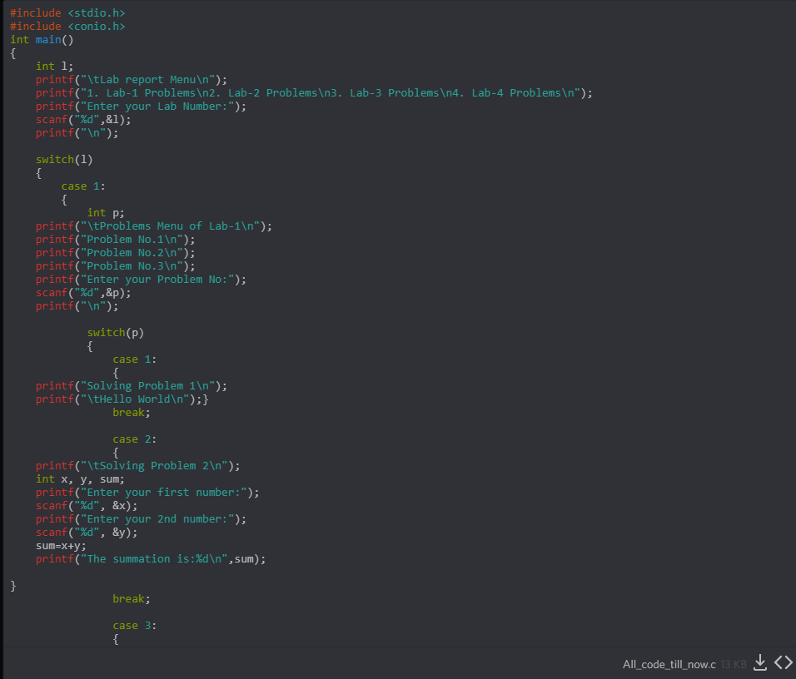
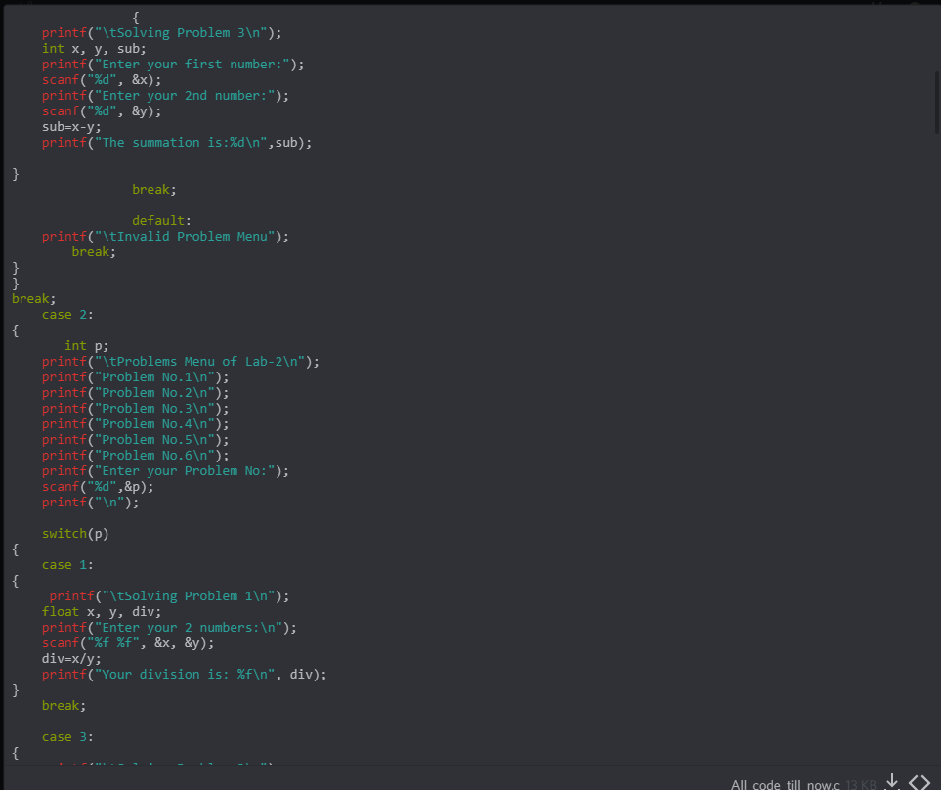
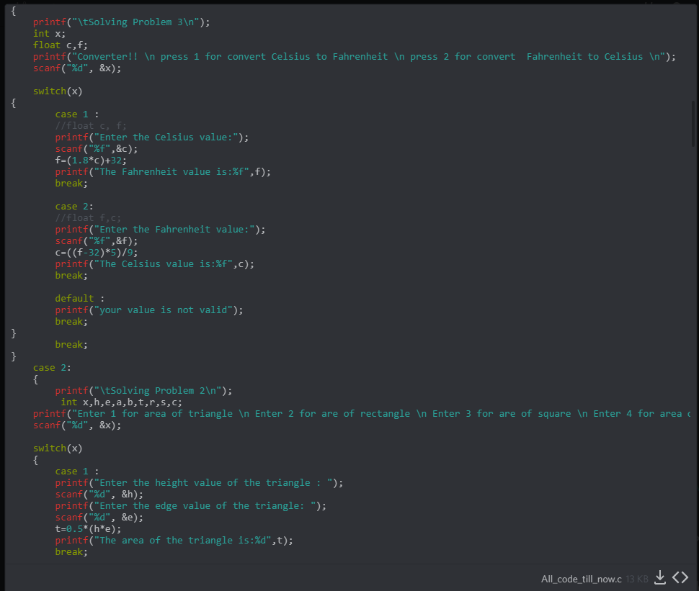

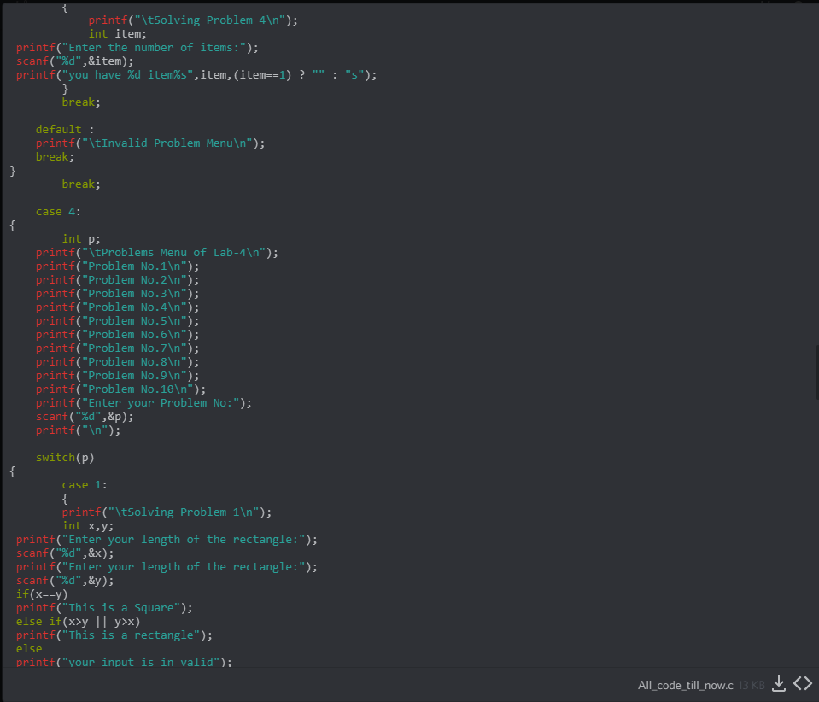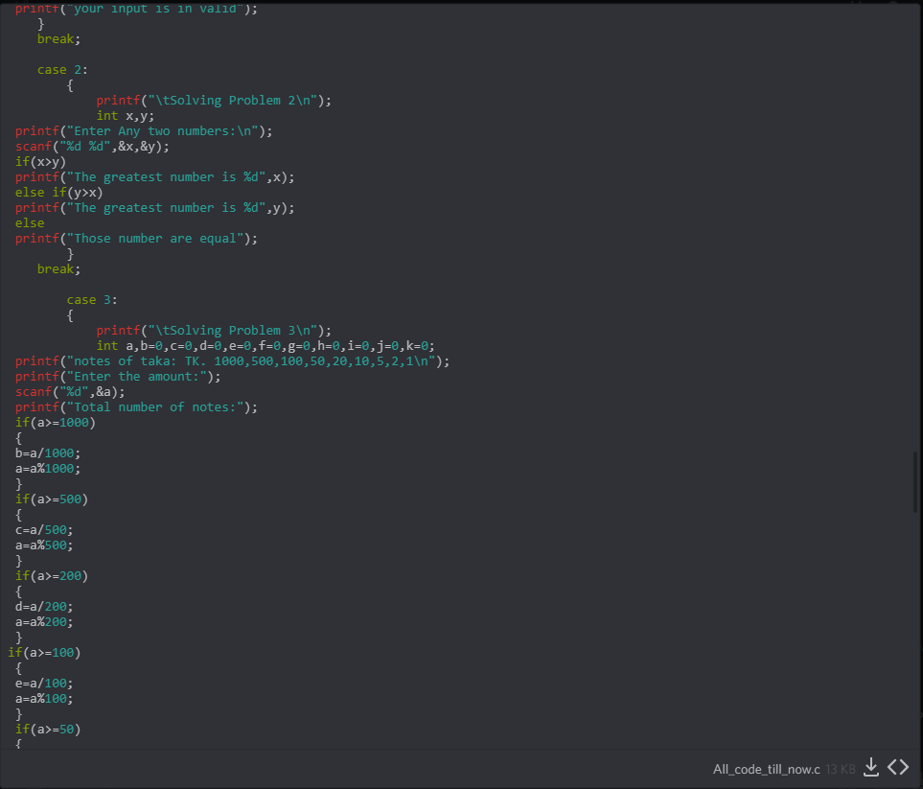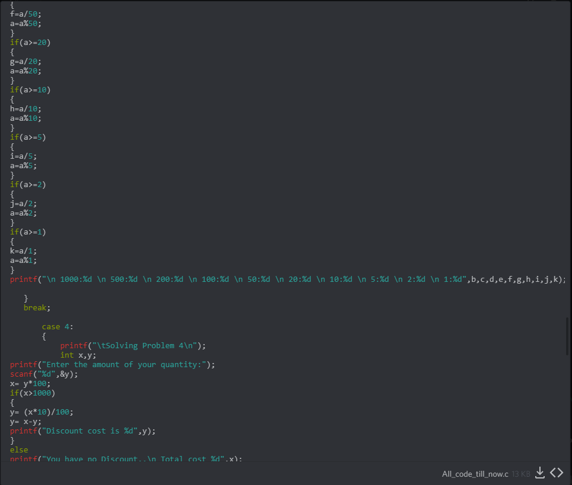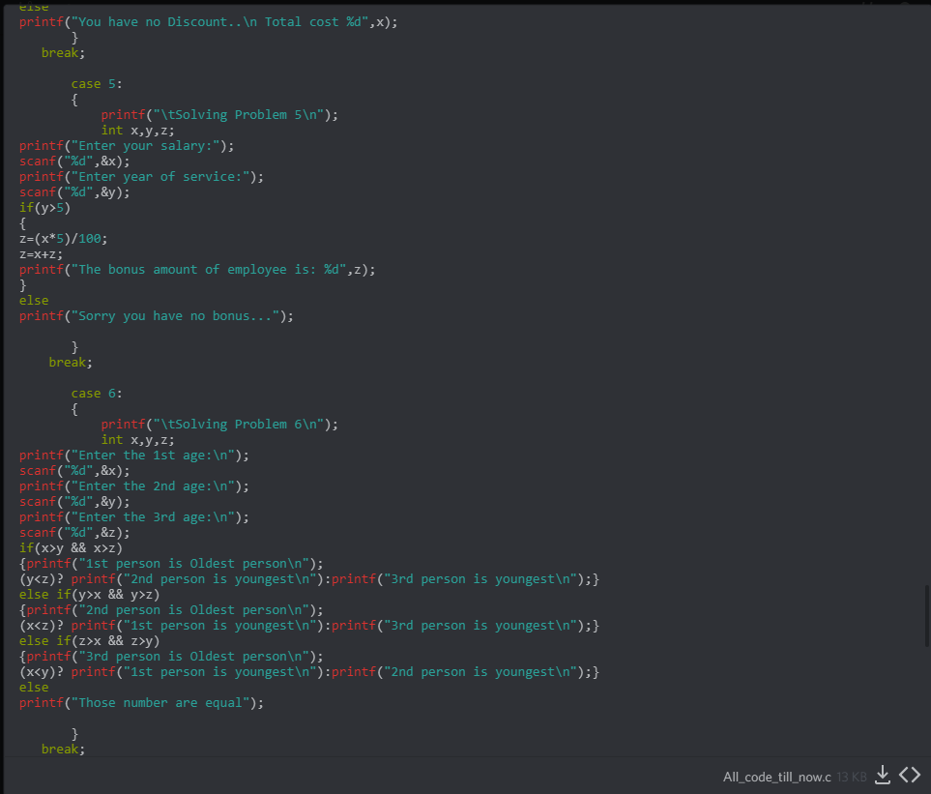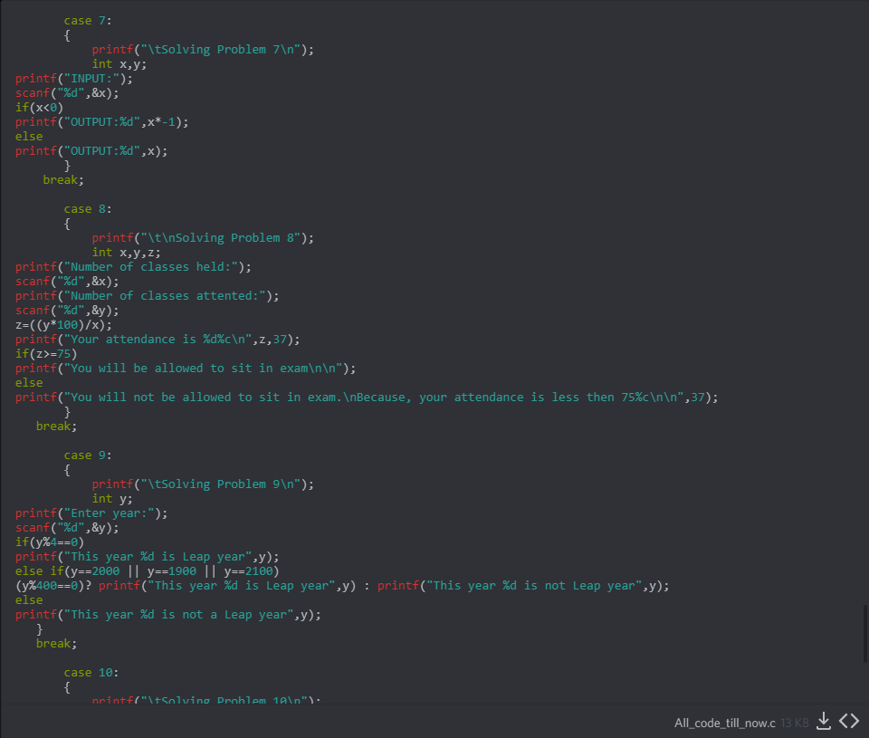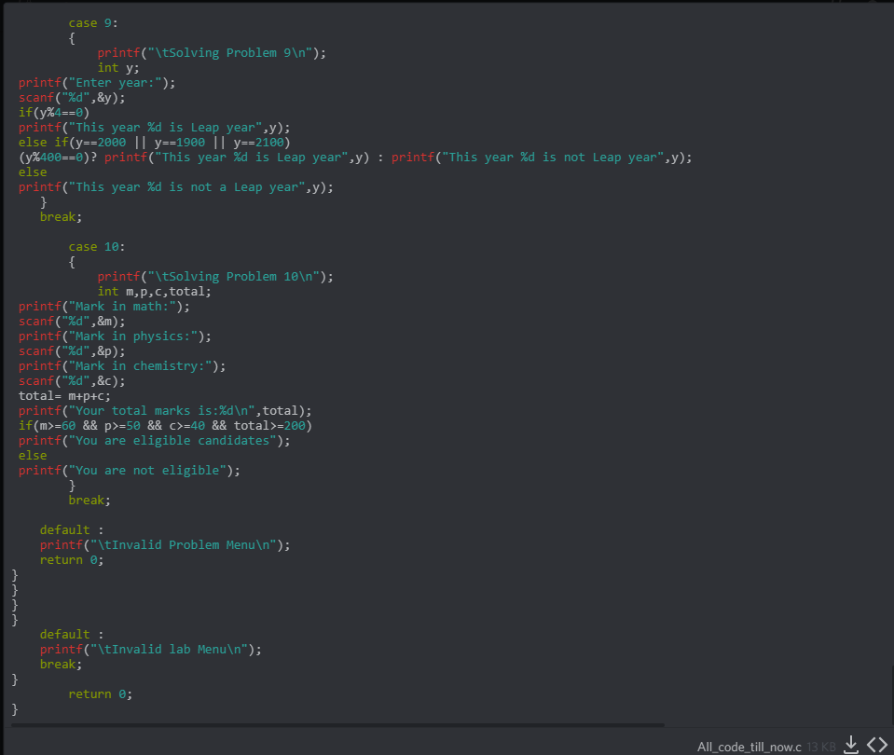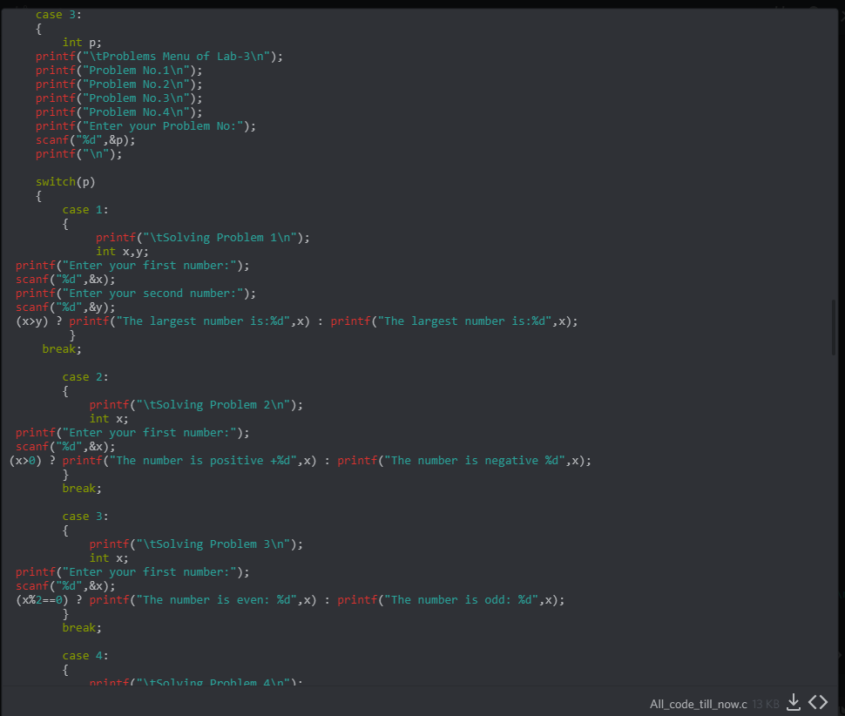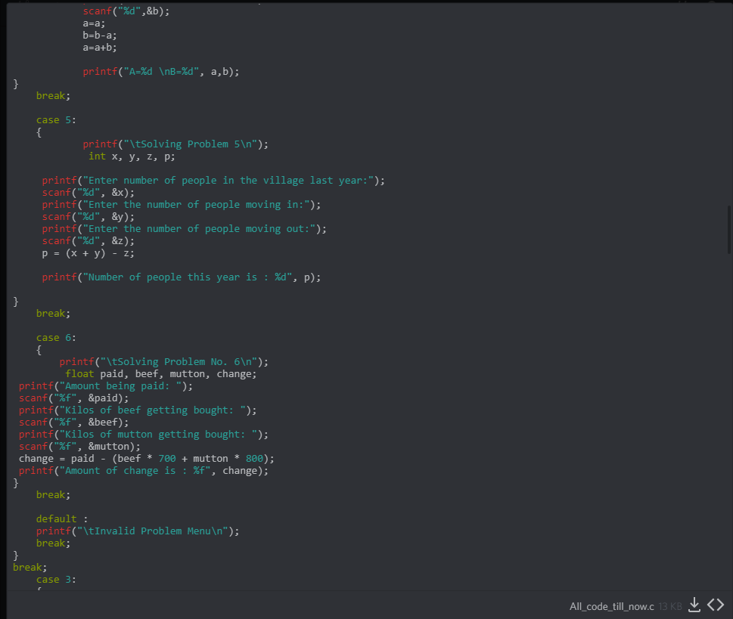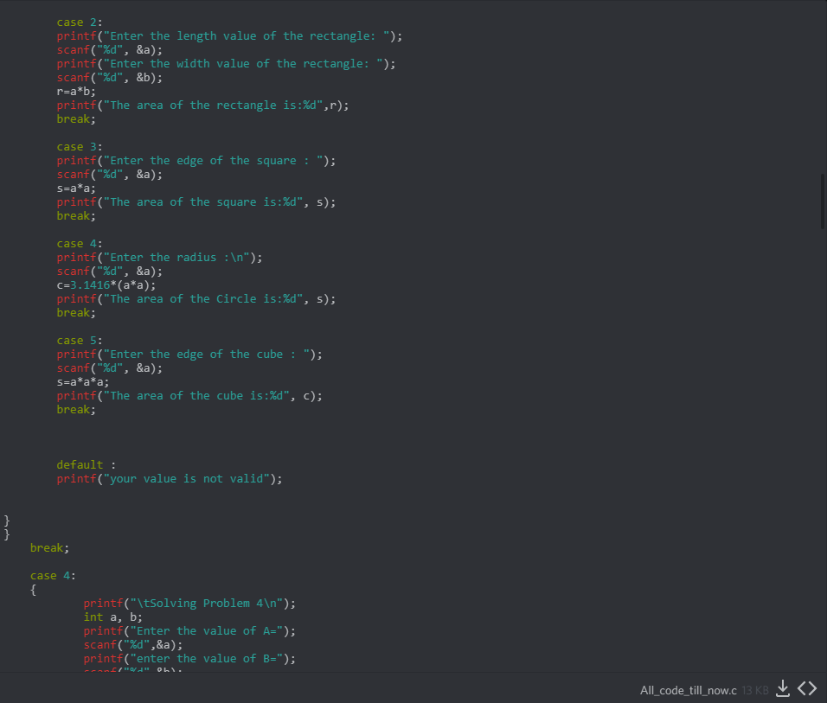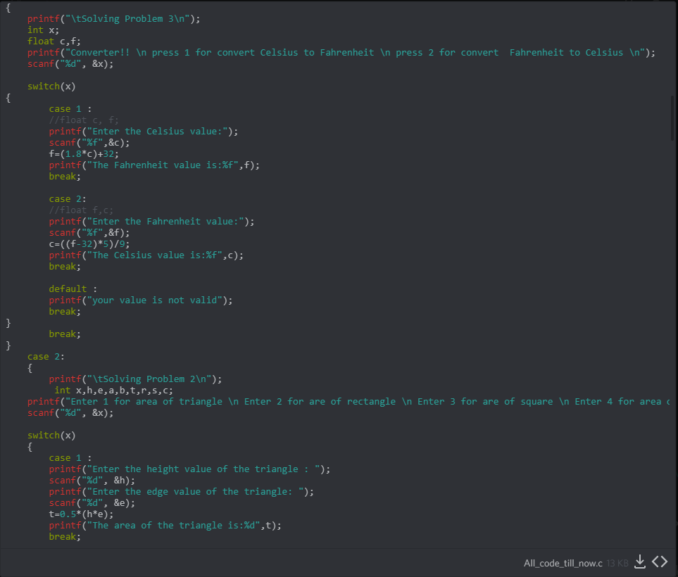

OutPut:

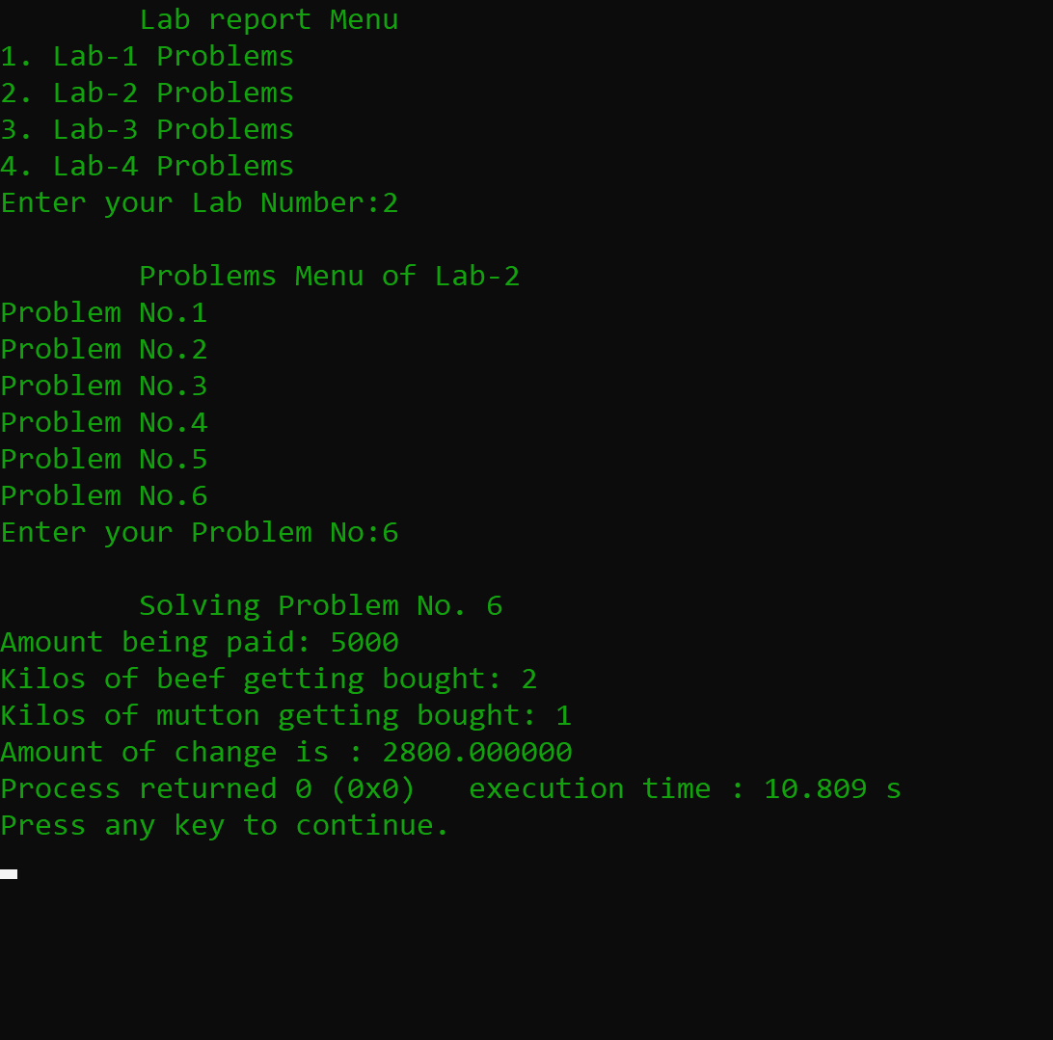
output 1
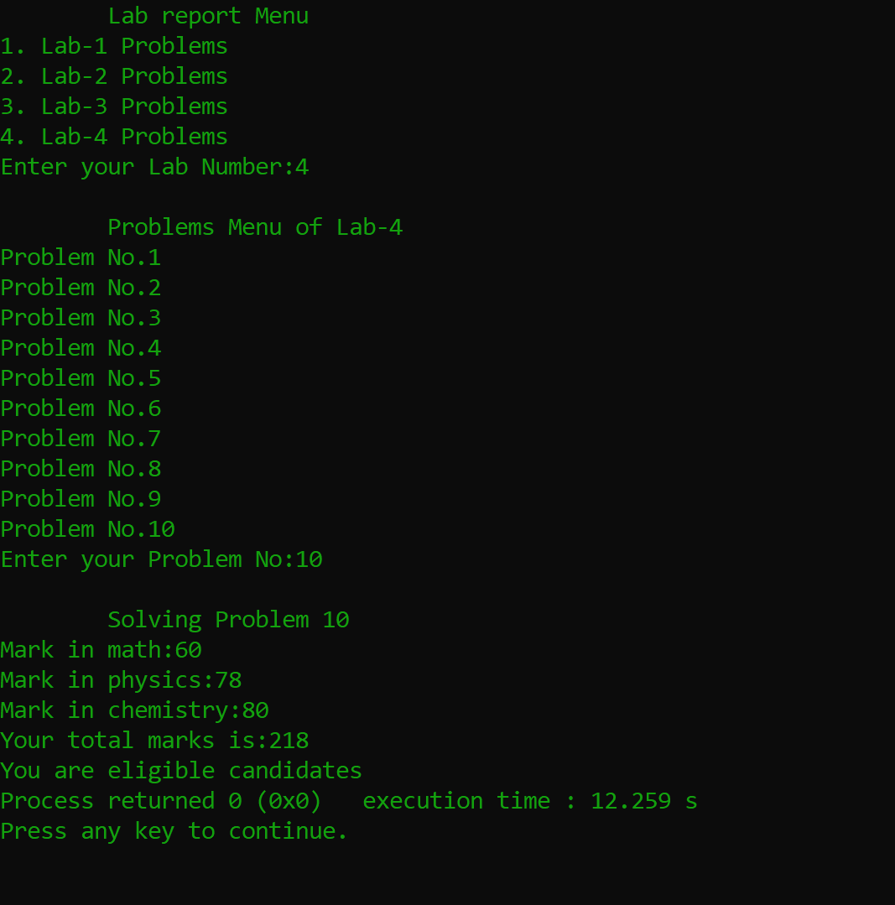
output 2
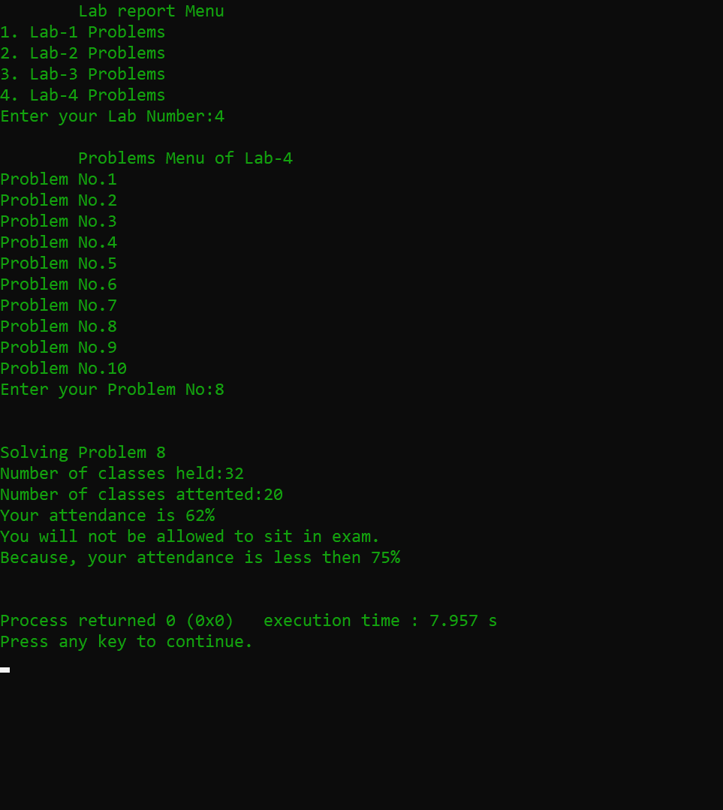
output 4
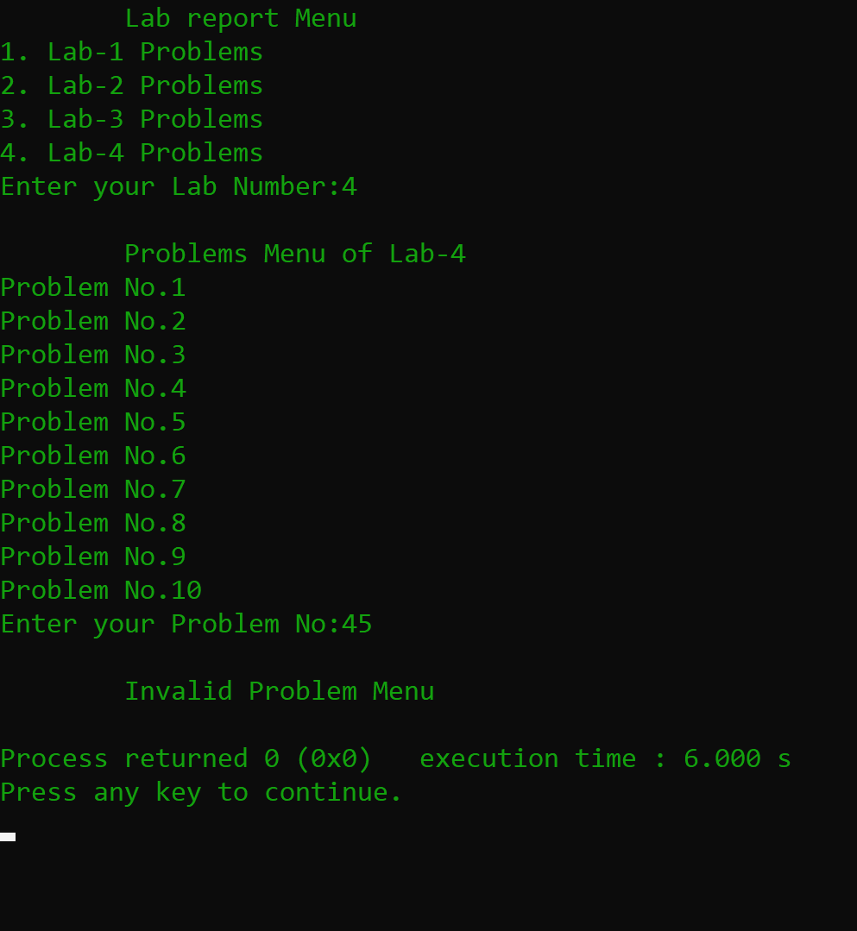
output 5

THE END

